**(System Concept)**

* **System:-** A set of detailed methods, procedures and routines created to carry out a specific activity, perform a duty, or solve a problem.Example-Computer,AC etc.
* **Procedure-**It is step-by-step sequence of activities that must be followed in the same order to correctly perform a task.
* **Method-** A method is a particular way of doing something .
* **Routine-** A routine is a usual or fixed way of doing things .
* **Type of System Operations**- There are five types operations are there in the system as:-

a) Inputting b) Processing c) Storing d) Controlling e) Output

* **System Component**- There are four types of system component as :-

a) **Hardware :**- Hardware is a physical component of the computer. To run a machine both hardware and software are required.

b) **Software**: Software is a set of instructions in the forms of programs. It can be control the sequence of operations.

c) **Data: -** Data is a raw material. Data is not meaningful. It can be used as input for the computer system.

d) **People/User: -** User can be perform various functions with the help of hardware and software to produce the desired output.

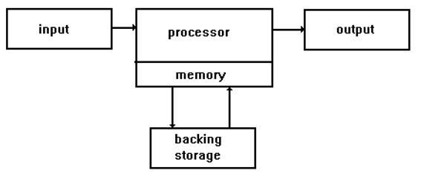

* **Type of System-** There are five types of system as:-

**a) Open System**- An open system is a system which interact with its environment being able to receive unexpected inputs. Example-Human Behaviour.

b) **Closed System**- A closed system is a system which does not interact with its environment but control its inputs . Example-Computer.

c) **Sub System**- A subsystem is a set of elements which is a system itself and a component of a larger system. A subsystem is a service provider that performs one function or many functions. Example- Parts of computer System.

d) **Super System-** A super system is a combination of things or parts forming a complex structure. A super system has major function. Example-Railroad system, Currency system.

e) **Adaptive System**- An adaptive system is a system that changes its behavior in response to its environment. The adaptive change that occurs is often relevant to achieving a goal . Example-Robots.

* **Information-** An information is a meaningful. Many data is a one information. An information can be used as output for the computer system. When data is processed, organized, structured presented in a given context .Example-GGI,BCA etc.
* **Data-** Data is a raw material of the computer. Data is not meaningful.Data does not depend on information. It can be used as input for the computer system. Example-upper case letter (A-Z), Lower case letter (a-z), Different number (12, 13.67),Different symbol as ($,*&,<?)
* **Knowledge-**Knowledge is an awareness of information, facts, ideas, truths. It is a clear awareness information .
* **Type of Knowledge-** There are two types of knowledge as:-

a) **Declarative knowledge** :- It involves knowing THAT something . It can be verbalized.

b) **Procedural knowledge**:- It involves knowing HOW to do something. We may not be able to explain how we do it.

* **Intelligence-** An intelligence to the ability of a computer to learn a specific task from data or experimental observation.